EX NO 4 Configuration and Analysis of SMTP and FTP Application-Layer Services using Cisco Packet Tracer
EX 4.1
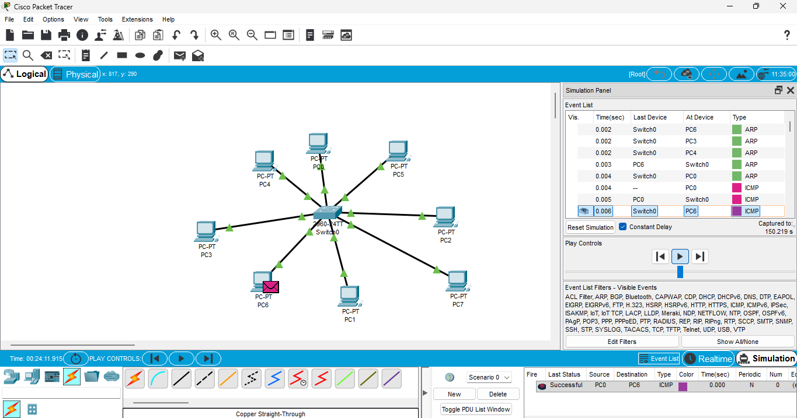
EX 4.2
